The REGISTers of the Jewish Community of Alexandria

HISTORY

The Ottoman Empire’s administration was based on the “Millet” system, which subdivided the non-Muslim population into religious groups (Orthodox, Jewish, Armenian etc.). These enjoyed a large degree of autonomy and as a counterpart were subject to certain obligations, mostly of a fiscal nature. The authorities accredited the spiritual leader who was sworn-in. Autonomy extended to intra-communal legal affairs, the educational system and particularly to the individual’s civil status with regards to births, marriages, divorces, deaths, and inheritance. Identity was ethnical


In Egypt, the organisation of the non-Muslim or non-Coptic communities into « Millet » subdivisions lasted, with slight modifications, until well after the fall of the Ottoman empire, throughout the establishment of independence and royalty from 1922, into the Republic declared in 1953. The civil status of stateless Jews, who were in the majority, was not affected by Egyptian independence. The religious civil status of foreign Jews was just as important to their respective Consulates, well after the abolition of Capitulations in 1936-37; indeed, some still rely upon it to this day. Egyptian Jews who depended on their religious civil status for their marriage still refer to it for the requirements of their recently acquired new nationality

IMPORTANCE


The Jewish Community of Alexandria, (whose development took off in the 1830’s, stood at 40000 individuals at its heyday and is now only 15 members strong), noted the civil status of its members in a number of registers. In order to better appreciate both the breadth of details and their innocuous character for Egypt, we present in this note the different types of existing registers. They pertain in no way to personal property. Their importance will best be understood free of any emotional controversy, at levels such as those of religious law, human rights, history and genealogy. We look at the problems of legitimacy, custody and preservation

Religious Importance (Halakhic):

In view of the fact that devolution of religious rights is strictly codified (Halakha), the registers bear a critically growing importance for those cases where it is necessary to
- Prove Jewish lineage even after one or a series of mixed marriages;
- Exercise one’s right to a Jewish burial.
Civil Importance :
In general, Jews from Egypt have established bona fide civil status documentation in their host countries, but community registers are still critical:
- In case of omitting to register with Consuls in Alexandria;
- In cases of theft or loss of documents necessitating reconstitution of civil status;
- In case of Nationality Certification;
- In cases of inheritance disputes.

Human Rights Importance :
The Registers, allowed for “Certificates” to be issued. When signing these certificates, the sworn-in religious authority bestowed on them proven authenticity and unquestionable credence by its sheer moral and physical presence. This authority no longer exists. The certificates, which are nevertheless still required by religious and civil authorities in other countries, are therefore no longer legitimate; at best they can be considered indicative. They will not even be issued, be it for civil or religious purposes, should they or the last members of the elderly community disappear.

We learn from articles 1°, 6° & 18° of the Universal Human Rights Declaration that:

- Art. 1: All human beings are born free and equal in dignity and rights.
- Art. 6: Everyone has the right to recognition everywhere as a person before the law.
- Art.18: Everyone has the right to freedom of …religion; this right includes freedom …to manifest his religion...in… practice, worship and observance.

It is therefore not unreasonable, for Jews from Egypt and their descendants, to lay claim to dignity, by recovering recognition of their personal status before the law, as it proceeded from the “Millet” system, in order to continue to exercise their religion in marriage and death and to prove their origins and bear witness to the past.

Historical & Genealogical Importance:
- It is extremely rare to find a series of documents bearing witness to the life of an important Jewish community, over a 150 years span. Various communities such as those of Izmir or Salonika have suffered from fire or plunder leading to the destruction of all documents. The Egyptian government has so far afforded protection, but time and climate will inevitably take their toll due to the lack of an appropriate infrastructure for the conservation of ancient documents. The historical importance of these documents is evident unless one were intent on obliterating any trace of Jewish presence in Alexandria.

- These documents cater for the growing interest in genealogical research. Alexandria as a Mediterranean magnet and crossroad was a catalyst for Sephardic and Ashkenazi genealogy.
Events were recorded either at the time of their occurrence in Alexandria, or authenticated on the basis of “Certified Affidavits”, if declared at a later stage or if occurring elsewhere. In these Certified Affidavits one finds civil status information, published banns, certificates of ‘good character’ including period photographs, details of family relationships and witnesses. Also used by descendants to locate a tomb or uncover a family link, this constitutes a wealth of genealogical detail.

Preserving this historical heritage and providing free access and availability to researchers would appear justified, unless one were to approve of their disappearance.

FORM

Information was recorded either on a line entry basis (Pinkassim), or on a pre -printed document (Soura of Ketoubot -Marriage contracts- or Affidavits). It was used to establish certificates (Chehadat). Affidavit registers are indexed. Documents are either in French, Italian, Hebrew or Arabic depending on their type or the epoch. Piecing together examples and various knowledgeable sources, one can estimate that there are over 255 registers ^{*= examples provided below} and 17 directories (indexes), which can be broken down as follows:

REGISTERS | N° | IND. | NOTES | EX.
CONVERSION SEFER HATAARAVOT | 1
CIRCUMCISION MILA | > 15 | 1 | By Mohel Itzhak Hasson, by Moshe Israel Hazan, & 3 by ShalomToubi. | *
COMING OF AGE bARMITZVA | 1 |  | 1500 Celebrations
ENGAGEMENTS | 13
MARRIAGES KETOUBOT | 53 | 10 | Of which 1 for marriages abroad;  Indexed by sex | *
WEDDINGS OF DESTITUTE CHILDREN Mohara Betoulot | 7
BIRTHS & MARRIAGES | 25 |  | From 1831 & noted on their occurrence in Alexandria | *
DIVORCES GUET | >/= 6 |  | Including 1 of foreign occurrence | *
DEATHS | > 16 | >/= 4 | From 1864; Indexed by sex | *
≈ GENERAL CERTIFIED AFFIDAVITS ≈ CELIBACY | 28 | 1 1 | From 1905 Publishing of Banns | * *
INDIVIDUAL OR FAMILY CIVIL STATUS AFFIDAVITS | 76 |  | From 1891. Declared later or foreign occurrence. | *
CITY OF TANTA | >/= 2
RABBINIC COURT  BET DIN | 12 |  | 1/2 Daily decisions & 1/2 Monthly ones.
TOTAL | > 255 | 17 |  | 8

CUSTODY

- As was demonstrated by the recent find of documents rotting in the basement, storage conditions are precarious. There are no back-up copies anywhere.
- The storage area is tiny and ill-equipped to counter climatic effects on ancient registers.
- The personnel are only available for 2 hours bi-weekly. Access times and period are even more limited for researchers, who are also stressed by the cumbersome presence of a one-on-one guard following acts of pilfering.
- Search for financial gain is already seeping through.
- Parties concerned are remote and those present are not qualified.
- The legitimacy of these civil status registers is vested only in an accepted genuine rabbinical authority which is required for proof of the religious and civil identity of descendants of the community.
It will be evident from the documents below, that the registers do not contain any information harmful to the Republic of Egypt; their protection and usage within their initial legal framework would be proof of enlightened and generous leadership.

Religious & civil importance

Certificate issued on the basis both of the “line entry” in the Circumcision Register (Pinkas HaMohel), confirmed by the Certified Affidavit Register. It forms the basis for a civil status document. Judaism is legally certified by Chief Rabbi Angel. In the absence of other documents, this will ensure a Jewish burial.
Circumcision
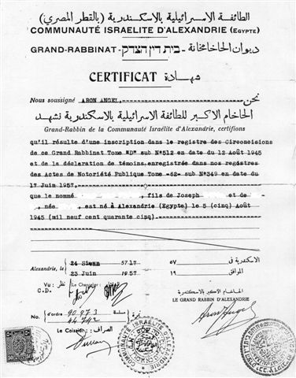

Seal of the Chief Rabbi & the Community

Copy of a Guet drawn from a Register of Divorce (Pinkas HaGuetine). It is a “line entry” on the day of the divorce. It sets out the conditions. This is relevant for estates following subsequent civil or religious remarriage.
DIVORCE

Importance for religious filiation

Copies (Soura) of Ketoubot drawn from the (pre- printed) Wedding Registers. These signed documents are the only legal proof of marriage, of its conditions, and therefore of the descendants’ religion.
MARIAGE

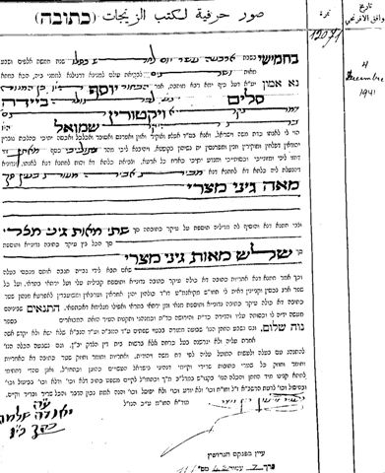

Left 1941, celebrated by C.R. Moïse Ventura.Uncial.

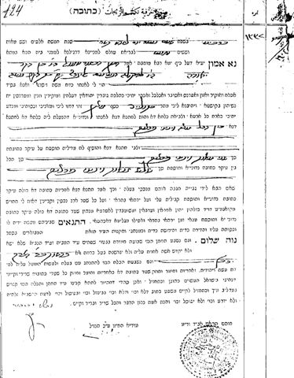

Right 1904, celebrated by C.R. Eliahou Hazan and R. Avraham Abigzir. Oriental Cursive.

Civil importance

These 2 Birth Certificates were drawn at the request of a foreign Consulate.
BIRTHS
They are based on Registers of Certified Affidavits

Left, 1932, correctly signed by « The Chief Rabbinate’s Chancellor ». Gratis.
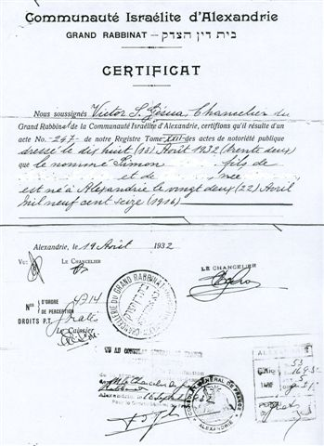
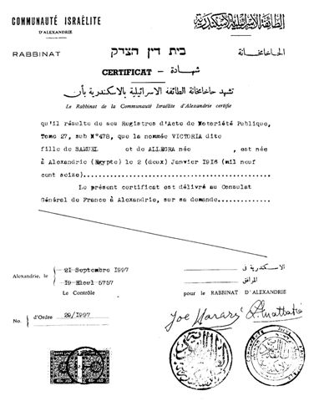

Consular Civil status

On the right, 1997, the Community seal is correctly used, but it is “the Rabbinate” (long gone!) which certifies. Issued free of charge despite a cost of 90 Piasters.
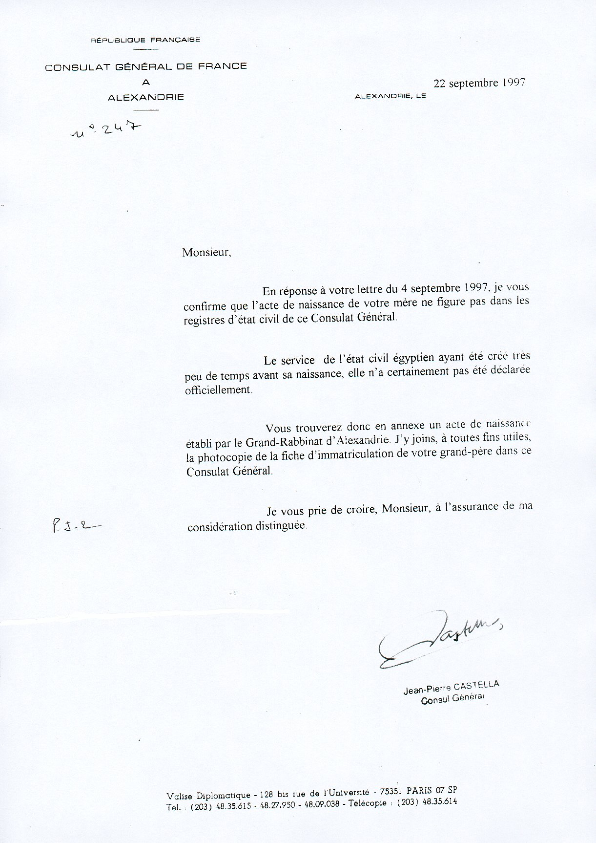

Even four generations as French nationals, does not automatically entail consular registration of one’s civil status. The Consulate relies on certificates of the Community, still called the “Chief Rabbinate”.
National Archives are incomplete for many families and inexistent for previously stateless Jews.

Historical & genealogical importance
DEATH

The 2 Death Certificates are drawn from a Death Register. For the city of Tanta, whose cemetery was razed, it is the only virtual evidence of burial.
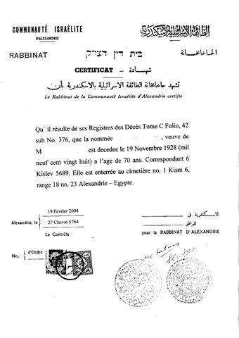
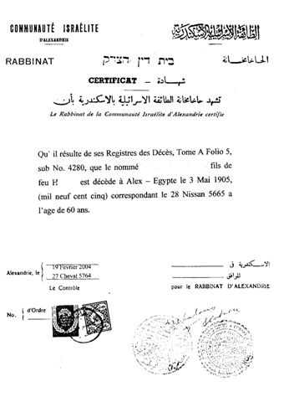
Issued by a “non existent Rabbinate” stamped at 100 Piasters, they are charged at 50 $ U.S. per document!

Indication of burial plot as of the late 1920’s

Strange! The Alexandria Grand Rabbinate seal of 1903 used inappropriately in 2004!

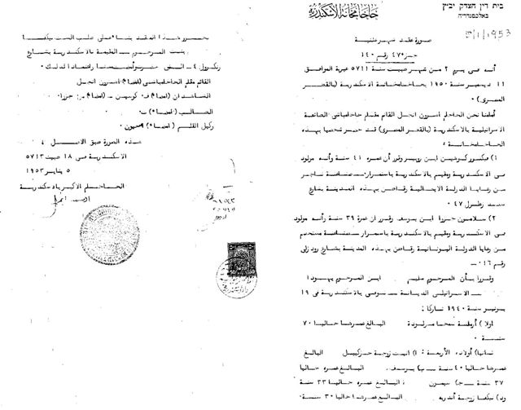
Reproduction (Soura) of a Certified Affidavit Register, in Arabic.
Affidavits

This document is a snapshot of a whole family: Place and date of birth and addresses for parents and siblings of the applicant.

Genealogical importance
Timbre approprié de 1919 utilisé par Grand Rabbinat 1953
CELIBACY AFFIDAVIT

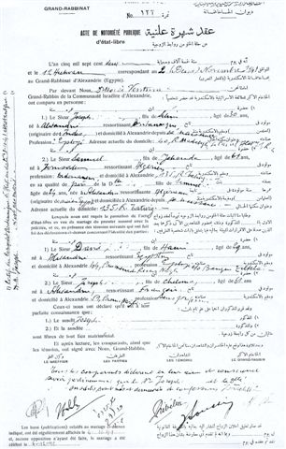

The photocopy of this “Celibacy” affidavit as it appears in the Affidavit Registers. It shows for the betrothed, their parents, & witnesses: place & date of birth, profession & residence, nationality & justifications. Signed by all parties, it confirms celibacy, religion and publication of banns.

British Consul’s O.K.

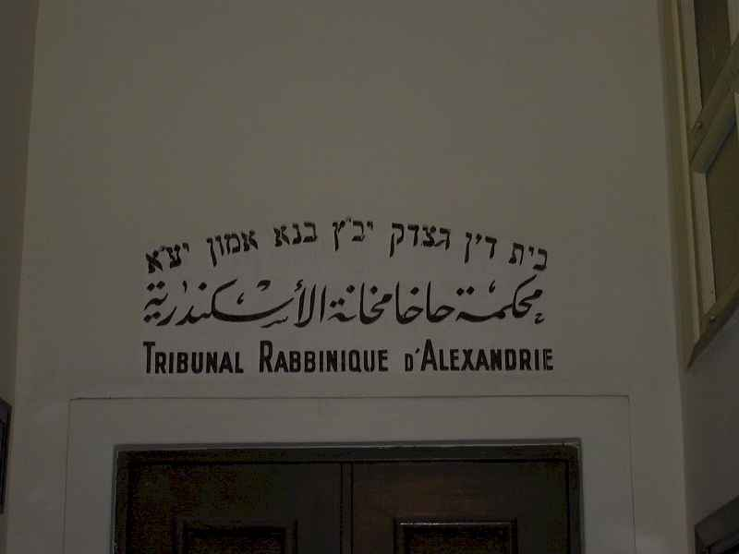
- Confronted with such a variety, availability, important but particularly innocuous nature of the registers to be protected…
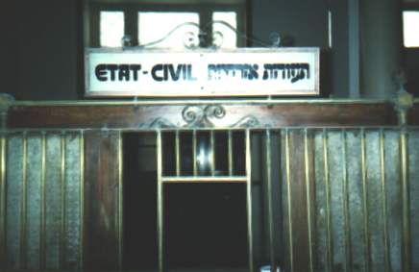
- Can one accept that these documents be voided of their legal nature regarding civil and religious status particularly important for marriage or death, that they be costly to issue and inaccessible for researchers whilst deprived of adequate preservation?
- Can one accept that the civil status of 100 000 individuals be left insecure and subject to the whimsical goodwill of a precarious management?

Genealogical importance

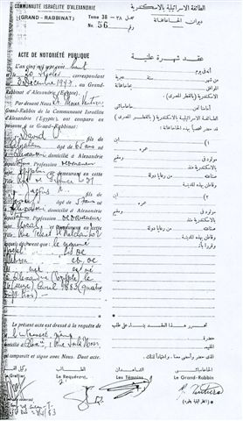
Certified Individual Affidavit

This document as it appears in the Affidavit Registers, shows place & date of birth, residence and applicant’s parents. Witnesses’ identity, profession, nationality and addresses are visible. Certified by all parties and the Chief Rabbi, it is the basis for birth certificates. It can reveal genealogical information.

PRESERVATION

The Association Internationale Nébi Daniel, therefore proposes to:
- Copy all these documents at its own expense;
- To place them under the auspices of the Consistoire Israelite and the authority of the Chief Rabbi of France.
- To treat them with due respect to individual privacy
- To digitize them for easier usage on the spot in Alexandria.
- To maintain all the community’s prerogatives in this respect.

In order to achieve this aim, authorisation from the highest authorities of the Egyptian government will permit
- To render this action legitimate and transparent for all governmental services concerned with the community’s security.
- To enable the community’s representatives to operate in conformity with a clear ruling.
Association Internationale Nébi Daniel
22, Cours Ferdinand de Lesseps, 92500 Rueil Malmaison, France
Mel : admin@nebidaniel.com Tel :33 (0) 609 26 14 37 Fax :33 (0) 141 96 87 31 - www.nebidaniel.com

